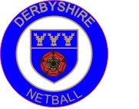

Athlete, Parent/Carer and County Contract

The offer and acceptance of a place in the Derbyshire County Under 13/Under 15 Player Development Programme forms a contract between the concerned parties and all agree:-

To abide by the terms of the appropriate Code of Conduct to their status – copies of which have been read by all parties and are available to be viewed on the Derbyshire Netball website.

To fulfil the commitment to the programme and attend all pre-determined dates to the best of their ability

That the athlete’s name and club are posted on the Derbyshire Netball website

That, unless any party specifically opts out in writing to the Programme Lead

Photographs of the athlete / volunteers are taken during activities and training and that these may be posted on the website

The athletes may be filmed during training/match play and that the videos will be used for performance analysis.

