Derbyshire County Under-15 and Under-13 Player Development Programme Selection Policy

Version | Reviewed By | Date | Next Review Date
02 | Derbyshire County Netball Player Pathway Management Group | May 2022 | May 2023

Policy Contents
Purpose & Scope of Policy 3
Performance Mission & Objectives 3
Eligibility 3
Selection Principles 3
Selection Process 4
The Selectors and Membership of Selection Panels 4
Appeals 5
Announcement & Notice 5
Injury & Replacement 6
Selection Criteria 7
Review Process 8
Confidentiality 8
General 8
Appendices 9
Appendix 1: Glossary of Terms 9
Appendix 2: County Under-15 Player Development Programme & County Under-13 Player Development Programme Selection Criteria 10
Appendix 3: England Netball Performance Pathway (May 2022) 14
Appendix 4: Loughborough Lightning Performance Pathway 15
Appendix 5: Derbyshire County Netball Code of Conduct & Guidance for Parents & Carers 16
Appendix 6: Derbyshire County Netball Code of Conduct for Athletes 17

1. | Purpose & Scope of Policy | This Selection Policy sets out how Athletes are selected by Derbyshire County Netball into the U13 and Under 15 County Player Development Programmes.  Appendix 1 contains the Glossary of Defined Terms. Those Terms will be applied throughout this document.
2. | Performance Mission & Objectives | Derbyshire County Netball are committed to delivering unprecedented and sustained on-court success, with high performance athletes, inspiring women and girls from across Derbyshire.  Through a robust, inclusive and transparent recruitment system Derbyshire County Netball aims to identify and select the right quantity and quality of Athletes to develop and sustain a successful county team and to be a major feeder to the Loughborough Lightning Academy squads (Appendix 4). This aspiration will guide all performance activity including Athlete recruitment activity, the management & delivery of the identification, and development of Athletes within the Academy Programmes. We may therefore offer opportunities on the basis of providing development opportunities to Athletes for future success.  The development of a leading county is dependent upon building a Squad of Athletes with depth and breadth across all positions on the court and the ability to function as an individual and in a team environment.
3. | Eligibility | Athletes may trial for and attend any County Player Development Programme in any county in order to provide choice for parents and Athletes.  To be eligible for Selection into the Derbyshire County Player Development Programme, an Athlete must:  - Be a current England Netball member  - Meet the Selection Criteria.  - Be selected / screened via the Derbyshire County Netball Selection and Screening process
4. | Selection Principles | The following principles will be applied in the course of carrying out the Selection Process:-  - The Derbyshire County Netball Selection Policy employs an open, transparent and equitable process that gives all Athletes a fair chance to challenge for selection.  - Selection will be based on merit and the need to achieve the agreed objectives of Derbyshire County Netball.  - No Athlete should have the right or expectation to on-going selection into Derbyshire County Netball Player Development Programmes.  - Each Selection Panel has the right to determine, at its sole discretion, whether it will re-select Athletes into County Player Development Programmes.  - Athletes and parents are required to sign Derbyshire County Netball Codes of Conduct (Appendices 5 & 6) in order to participate in Derbyshire County Netball Player Development Programmes. Athletes may be subject to de-selection if they breach the Codes of Conduct or any other relevant Derbyshire County Netball policies or regulations.  - The relevant Head Coach has the right to invite Athletes from outside of Derbyshire County Netball Programmes to be observed and considered for inclusion in the Programmes.  - Regard will be made to the combination and balance of Athletes in Programmes, and the ability of Athletes to play in more than one position, alongside each Athlete’s individual skill level.
5. | Selection Process | The process of selection for Player Development Programmes is as follows:-  - Athlete performance at Derbyshire County Under-15 Player Development Programme trials and County Under-13 Player Development Programme trials will be observed and assessed independently and against the Selection Criteria as set out in Appendix 2 and agreed by the Derbyshire County Netball Player Pathway Management Group.  - Following completion of the Derbyshire County Under-15 Player Development Programme trials and County Under-13 Player Development Programme trials, the coach might consult with other identified coaches and consider any relevant input from them.  - The nominated Athletes will be those that, in the expert opinion of the Head Coach, are most able to achieve the objectives of Derbyshire County Netball set out in the Performance Mission and Objectives section above.  - The Head Coach will meet with the Selection Panel to discuss the Nominated Athletes and provide the opportunity for the members of the Selection Panel to check and challenge and ensure Athlete selection decisions are evidence-based, taking into account the selection criteria outlined in this Selection Policy.  - Individual Athlete’s inclusion into Derbyshire County Netball Player Development Programmes will be decided on a majority vote by all members of the Selection Panel.  - If a majority decision cannot be reached by the Selection Panel because the votes are equally split , the matter will be referred to the Chair of Selectors, the Coach and the Head Athlete Identifier (or a suitable deputy appointed by the County Player Development Lead in the absence of the Head Athlete Identifier) to make the final decision.
6. | The Selectors and Membership of Selection Panels | A Selection Panel will be established by Derbyshire County Netball Player Pathway Management Group for selecting Athletes into Programmes.  The Membership of Selection Panels is set out in the below:-  - Selection Panel members will be appointed by Derbyshire County Netball’s Player Development Lead.  - All Selectors, including the Chairs, will be selected from the Derbyshire County Netball Player Pathway Management Group and appointed based upon competency for the role, with an annual review. All selectors will be required to declare any conflicts of interest (for example, being connected to a school, club, league, VNSL franchise).  - All Selection Panel members are accountable to Derbyshire County Netball’s Player Development Lead and ultimately Derbyshire County Netball’s Board for ensuring that this Selection Policy and all associated procedures are applied in a fair and appropriate manner.  - Any individual Athlete’s inclusion in Derbyshire County Netball Player Development Programmes is decided on a majority vote by all members of the relevant Selection Panel.  Derbyshire County Under-15 Selection Panel  - Under-15 County Player Development Programme Head Coach (one vote)  - A designated member of the coaching team appointed by the County Player Development Lead (one vote)  - Independent Selector (one vote)  - Chair of Selectors (no vote)  Derbyshire County Under-13 Selection Panel  - Under-13 County Player Development Programme Head Coach (one vote)  - A designated member of the coaching team appointed by the County Player Development Lead (one vote)  - Independent Selector (one vote)  - Chair of Selectors (no vote)  At the discretion of Derbyshire County Netball’s Player Development Lead, additional personnel may be invited to observe and / or provide information to the selection process, but will not participate in any voting, and will be bound by the principle of confidentiality outlined below.
7. | Appeals | Appeals can only be submitted by a non-selected (or de-selected) Athlete on the grounds that:  - The process outlined within this policy has not been adhered to; or  - The process failed to take into consideration relevant information; or  - The process failed to consider relevant information, which was available at the time, which the Athlete Identifier Panel did not consider.  An Athlete may request an appeal only on the grounds listed above by submitting a written request to the Derbyshire County Player Development Lead. Any appeal shall be made within 3 working days of the communication to the Athlete regarding the decision or announcement.  Appeals should be made following the “Derbyshire County Netball Under-15 County Player Development Programme and Under-13 Player Development Programme: Appeals Process” attached – further details can be found on the Derbyshire County Netball website
8. | Announcement & Notice | Derbyshire County Netball Under-15 County Player Development Programme and Under-13 Player Development Programme Announcement:  - Provisional invitations to selected Athletes will be made 3 working days after the relevant Selection Panel meeting.  - Athletes invited are required to sign and return their Codes of Conducts (Appendices 5 & 6) within 3 working days of issue.  - Announcements of the Athletes selected into Derbyshire County Netball Player Development Programmes will take place via email once all athletes have confirmed their place and all Codes of Conducts have been returned.  - Notification to selected Athletes selected for any competitions or tournaments will ordinarily be announced via email in advance of each match.  Derbyshire County Netball will endeavour to allow time for appeals to be heard and dealt with before external announcements regarding selection are made. However, there may be circumstances in which selection announcements have to be made externally whilst appeals may still be ongoing.  Athletes selected into Derbyshire County Netball Player Development Programmes agree not to make any announcement regarding their selection until approved to do so or made public by Derbyshire County Netball.
9. | Injury & Replacement | An Athlete may be removed from Derbyshire County Netball Player Development Programme in the event of:  - no longer being fully available to participate in the Programme for which they were selected  - non-compliance in training,  - a breach of responsibility,  - a violation of the codes of behaviour as per Codes of Conduct (Appendices 5 & 6)  - failure to reach Derbyshire County Netball’s performance expectations in training (see below)  - an inability to compete to the best of her ability due to an injury and/or illness (see below)  - consistent unexplained absences from training  Failure to Reach Derbyshire County Netball’s Performance Expectations  The following process will be followed:  Prior to confirmation of de-selection, the Athlete or the Athlete’s appointed representative will be presented with the opportunity to attend a de-selection meeting with Derbyshire County Netball’s Player Development Lead and/or relevant Head Coach and, where possible, one other independent person. Written justification must be provided for all removals and will be provided either when the Athlete is put at risk of de-selection or following the de-selection interview.  Decisions on de-selection are open to appeal under the appeals process set out in the Appeals section above and the “Derbyshire County Netball Under-15 County Player Development Programme and Under-13 Player Development Programme: Appeals Process” found on Derbyshire County Netball website.  An Inability To Compete Due To An Injury and/or Illness  The following process will be followed:  Athletes must not withhold any information on training fitness, injury status or illness that could affect training or competition at any time.  At any stage following the selection of an Athlete to Derbyshire County Netball’s Player Development Programmes, should there be any doubt over the ability of a selected Athlete to compete to the best of their ability due to an injury and/or illness, the following procedure will be adhered to:  - If Derbyshire County Netball has concerns over whether or not the Athlete is able to compete to the best of their ability due to an underlying injury and/or illness the Athlete will first be invited to a discussion with a Derbyshire County Netball representative with a parent/guardian present.  - The Athlete may be required to undertake fitness testing to be completed under ‘controlled competition conditions’ to determine Athlete fitness.  - In the event that an Athlete fails to complete the testing to the required standard, a Derbyshire County Netball representative may recommend that the selected Athlete be de-selected and replaced with a reserve. The decision is open to appeal under the appeals process set out in the Appeals section above and the “ Derbyshire County Netball Under-15 County Player Development Programme and Under-13 Player Development Programme: Appeals Process ” found on Derbyshire County Netball website.
10. | Selection Criteria | Whenever selecting Athletes for Derbyshire County Netball Player Development Programmes, the Selection Panel shall apply the Selection Criteria (Appendix 2). A grading of 1-4 will be applied when assessing against any and all such selection criteria, with 4 being the highest grading.  The Selection Panel will also consider ‘other factors’ listed below within their final selection decisions and will seek to ensure subjective opinions are supported by evidence.  Other factors considered will include:  - Availability of the athlete to fully participate in the Programme  - Coachability: the athlete understands expectations and can apply learning and make changes  - Demonstrates the ability to operate effectively within a team  - State of fitness, health and wellbeing  - Positional balance and combinations within the team  - Succession planning  - Number of fixtures on the annual competition calendar  - Focus of the current year  - Current form or performance  - Balance of experience and youth  - Progress made by the athlete in the previous 12 months  - Whether an Athlete’s performance and/or contribution has been affected by extenuating circumstances such as illness, injury, bereavement, parental leave, work/study commitments or similar which have temporarily compromised their form and/or recent contribution.  Consideration may also be given to any other such factors that the Selection Panel considers in its sole discretion to be relevant and appropriate to the overall assessment of a particular Athlete.
11. | Review Process | Derbyshire County Netball’s Player Pathway Management Group will review this Selection Policy on an annual basis. Proposed changes to this Selection Policy must be approved by the Derbyshire County Netball Board. Any amendments to this Selection Policy must be given in writing to the Athletes, Head Coaches and other Selection Panel members and other key stakeholders. This Selection Policy (including any final variations or amendments) will be made available on the Derbyshire County Netball website and made available to all Athletes on request.
12. | Confidentiality | All those involved in the nomination and selection process must keep confidential and not disclose any information regarding any aspect of the process and/or any nominated or selected Athlete, unless authorised by Derbyshire County Netball.
13. | General | Insofar as is permitted by law, Derbyshire County Netball and its authorised agents do not accept liability for any loss or damage occurring as a result of the selection process. This shall not affect any statutory rights that are available and this shall not limit or exclude any liability that may not be excluded or limited by law.  If there is any reason to believe that there has been a breach of this Selection Policy or any related terms and conditions, then Derbyshire County Netball at its sole discretion, may exclude any Athlete from participating in the selection process.  This Selection Policy shall be governed by English law and, subject to the operation of any appeals as set out in the Appeals section above and the “Derbyshire County Netball Under-15 County Player Development Programme and Under-13 Player Development Programme: Appeals Process” found on the Derbyshire County Netball website.

Appendices

Appendix 1: Glossary of Terms
Term | Definition
Athlete | Netball Players
Coach | The Head Coach (or age group Lead Coach for all age group squads).
County Player Development Programme | Netball performed within the Derbyshire County Player Development Programme.
Programme | This includes the training and competition environment for all County Player Development Programme Athletes.
Selection Criteria | Statements relating to skills, attributes and game sense used to select Athletes into Derbyshire County Player Development Programmes.
Selection Panel | Personnel appointed by the Head Performance Identifier to make Selection decisions.
Athlete identifiers | Appointed by Derbyshire County Netball (or a suitable deputy appointed by the County Player Development Lead in the absence of the Head Athlete Identifier)

Appendix 2: County Under-15 Player Development Programme & County Under-13 Player Development Programme Selection Criteria

Whenever selecting Athletes for Derbyshire County Netball Player Development Programmes, the Selection Panel shall apply in all Identifying activities:

- Evidence of Skill or Quality
- Demonstrate Consistency
Game Sense Under-15 & Under-13 Criteria
Attack | Defence | Behaviours
Transition  Width/Depth  Options / Choices  Ball Side  Maintaining Possession | Transition  Winning Ball  Working Together  Delay / Deny Opportunity  Dictating | Thinking  Patience  Never Give up  Leadership
- Demonstrate Under Pressure
Movement Skills Under-15 & Under-13 Criteria
Take Off | - Demonstrate an effective technique from a stationary and moving start  - Straight movement forwards and backwards  - Diagonal movement to the left and right
Footwork | - Demonstrates efficient running technique  - Able to Sprint and change direction  - Able to side step  - Speed of footwork  - Recovery footwork  - Ability to work in a number of combinations  - Turning from a sprint movement
Jumping | - Demonstrate efficient technique  - Able to jump from both feet simultaneously  - Able to jump off left or right foot  - Able to turn in the air
Landing | - Demonstrate safe and balanced technique  - Able to land on left and right foot  - Able to land on both feet simultaneously  - Able to pivot in all directions with an outside turn
Ball Handling | - Catching 2 and 1 handed  - Passing 2 handed and 1 handed with a variety of passes used  - With and without a defender
- Demonstrate in multiple contexts with consistency

Considerations will also be made as to whether Athletes; are willing to learn, display resilience, are a thinker/decision maker, are confident and take risks

Positional Specific Under-15 & Under-13 Criteria
GS | Movement & Ball Handling | - Change of direction and change of pace  - Lands balanced, turns to goal  - Available and able to deliver an accurate pass  - Sound catching technique  - High release point and a variety of passes used  - Sprint, Change of direction, Change of pace, ability to move in multi-directions – back to go forward/forward to go back | Effectiveness in Position | - Confident from a range of distances  - Prepared to shoot  - Accurate shooting technique, aiming for >80% accuracy  - Aware of the GA  - Attempts to win rebound  - Is generally available when centre court hit the circle edge  - Available in a 1:1 situation  - Spatial awareness – balance in relation to other Athletes when attacking | Transition | - Dictates to opponent to limit her availability through the court  - Able to apply defensive pressure by using stage 1 & 2. Possibly some indication of stage 3  - Ability to go and go again (Re-offer)
GA |  | - Change of direction and change of pace  - Lands balanced, turns to goal  - Available and able to deliver an accurate pass  - Sound catching technique  - High release point and a variety of passes used  - Sprint, Change of direction, Change of pace, ability to move in multi-directions – back to go forward/forward to go back |  | - Confident from a range of distances  - Prepared to shoot  - Accurate shooting technique, aiming for >80% accuracy  - Aware of the GS, WA and C  - Attempts to win rebound  - Is generally available when centre court hit circle edge  - Gains depth in 2nd Phase of the Centre Pass if the ball is not received in 1st Phase  - Available in the attacking circle and in the attacking third  - Is generally available 1st phase on Centre Pass when required  - Spatial awareness – balance in relation to other Athletes when attacking |  | - Dictates to opponent to limit her availability through the court  - Able to apply defensive pressure by using stage 1 & 2. Possibly some indication of stage 3  - Ability to go and go again (Re-offer)
WA |  | - Change of direction and change of pace  - Lands balanced, turns to goal  - Available and able to deliver an accurate pass  - Sound catching technique  - High release point and a variety of passes used  - Sprint, Change of direction, Change of pace, ability to move in multi-directions – back to go forward/forward to go back |  | - Is generally available at 1st phase Centre Pass  - Accurate feeds into shooters  - Maintains possession  - Available on circle edge with movement on and off circle edge in relation to the C  - Aware of GA at Centre Pass  - Can gain depth during phase 2 of the CP if does not receive the Centre Pass at Phase 1  - Spatial awareness – balance in relation to other Athletes when attacking |  | - Dictates to opponent to limit her availability through the court  - May take interceptions  - Able to apply defensive pressure by using stage 1 & 2. Possibly some indication of stage 3  - Ability to go and go again (Re-offer)
C |  | - Change of direction and change of pace  - Lands balanced, turns to goal  - Available and able to deliver an accurate pass  - Sound catching technique  - High release point and a variety of passes used  - Sprint, Change of direction, Change of pace, ability to move in multi-directions – back to go forward/forward to go back |  | - Deliver Centre Pass  - Links and connects both attack and defence  - Accurate feeds into shooters  - Maintains possession  - Available on circle edge with movement on and off circle edge in relation to the WA  - Spatial awareness – balance in relation to other Athletes when attacking |  | - Shows signs of working effectively with the WD for effective 2 on 1 at Centre Pass  - Able to apply defensive pressure by using stage 1 & 2. Possibly some indication of stage 3  - Ability to go and go again (Re-offer)
WD |  | - Change of direction and change of pace  - Lands balanced, turns to goal  - Available and able to deliver an accurate pass  - Sound catching technique  - High release point and a variety of passes used  - Sprint, Change of direction, Change of pace, ability to move in multi-directions – back to go forward/forward to go back |  | - Effective defending at Centre Pass/Puts pressure on receipt of WA on 1st Phase of Centre Pass  - Dictates WA movement in the attacking third  - Puts pressure on feeds  - Gains possession & Wins ball  - Spatial awareness – balance in relation to other Athletes when attacking  - Able to reset in relation to the GD on attacking third line |  | - Transitions from defence to attack providing option for the initial turnover  - Able to apply defensive pressure by using stage 1 & 2. Possibly some indication of stage 3  - Ability to go and go again (Re-offer)
GD |  | - Change of direction and change of pace  - Lands balanced, turns to goal  - Available and able to deliver an accurate pass  - Sound catching technique  - High release point and a variety of passes used  - Able to adjust body angle to see the ball and player  - Sprint, Change of direction, Change of pace, ability to move in multi-directions – back to go forward/forward to go back |  | - Puts pressure on receipt of GA on 1st Phase of Centre Pass  - Dictates and restricts GA movement  - Limits shot volume  - Pressure on the shot  - Attempts to win rebound  - Gains possession & Wins ball  - Challenges for rebounds  - Spatial awareness – balance in relation to other Athletes when attacking  - Able to reset in relation to the WD on attacking third line |  | - Transitions from defence to attack providing option for the initial turnover  - Able to apply defensive pressure by using stage 1 & 2. Possibly some indication of stage 3  - Ability to go and go again (Re-offer)
GK |  | - Change of direction and change of pace  - Lands balanced, turns to goal  - Available and able to deliver an accurate pass  - Sound catching technique  - High release point and a variety of passes used  - Able to adjust body angle to see the ball and player  - Sprint, Change of direction, Change of pace, ability to move in multi-directions – back to go forward/forward to go back |  | - Dictates and restricts GS movement  - Limits shot volume  - Pressure on the shot  - Attempts to win rebound  - Gains possession & Wins ball  - Challenges for rebounds  - Spatial awareness – balance in relation to other Athletes when attacking |  | - Transitions from defence to attack providing an option on 1st Phase  - Delivery of the back line pass with success  - Able to apply defensive pressure by using stage 1 & 2. Possibly some indication of stage 3  - Ability to go and go again (Re-offer)

Appendix 3: England Netball Performance Pathway (May 2022)

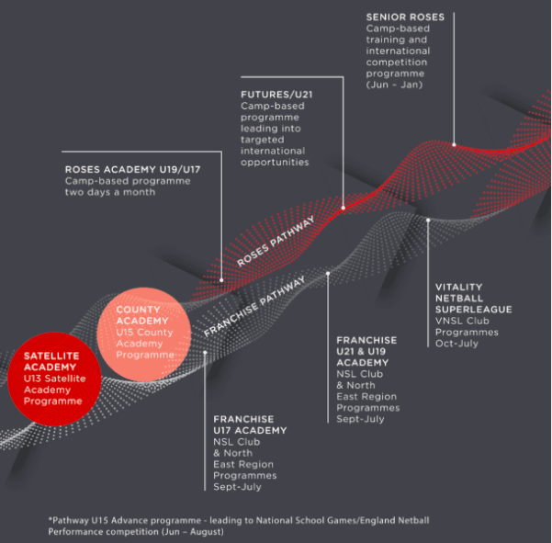

Appendix 4: Loughborough Lightning Performance Pathway

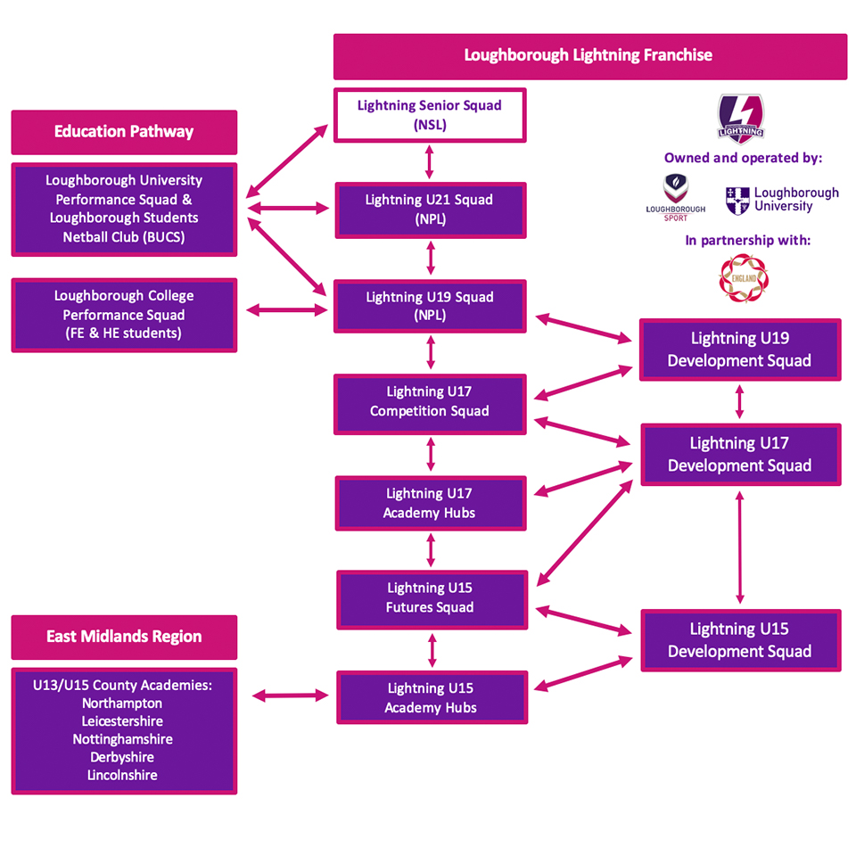

Appendix 5: Derbyshire County Netball Code of Conduct & Guidance for Parents & Carers

In order to gain the best experience from their involvement in sport, children and young people generally rely on their parents/carers for both emotional and financial support. This influence can be even more critical if their child becomes involved in national squads and competition. It is hoped that the following will prove useful to parents/carers to support their child to participate in and enjoy netball.
- Support your child’s involvement and help them to enjoy all that netball has to offer;
- Encourage respect for the rules of netball, promote and support fair play and the acceptance of an official’s decision;
- Encourage recognition of good performance in others as well as themselves;
- Do not applaud opponent’s errors or their misfortune;
- Uphold high standards of behaviour, appearance and promote the importance of being a good team player;
- Establish a positive partnership with the coach in order to help provide the best possible balance between the demands of netball, education and home;
- Ensure that your child is aware of all the arrangements made for matches, training, tours and trips;
- Be punctual when collecting or delivering your child to training or matches;
- Ensure that your child fully understands the requirements of the Codes of Conducts for Athletes;
- Never exert undue pressure on your child to complete or to gain results. Be realistic about your child’s ability;
- Always use appropriate language and ensure your child does the same;
- Under no circumstances condone a rule violation or the use of prohibited substances including alcohol and tobacco;
- Ensure that your child understands that they should take an appropriate level of responsibility for their own safety;
- Show respect to the coach/volunteer working with your child;
- If you have questions or queries, communicate these to the coach/volunteer to enable any concerns to be understood and responded to. A culture of openness is encouraged and it may be possible (and important) to ensure that your child can contribute to any such discussions to enable their views to be considered;
- Any concerns that parents/carers feel unable to address directly with the coach/volunteer should be discussed with the Safeguarding Officer;
- Encourage your child to take responsibility for their own actions;
- You should immediately inform your child’s coach or team manager of an injury or illness that affects your child which might impact upon their ability to train or compete;

Athletes Name: ……………………………………………………..

Athletes Signature: ………………….……………………………………..

Date: ……………………………….

Appendix 6: Derbyshire County Netball Code of Conduct for Athletes

Derbyshire County Netball’s Code of Conduct requires the highest standards of conduct from everyone involved in netball to ensure that their behaviour and actions meet the values and standards expected at all times. Everyone must conduct themselves in an honest, fair, impartial and transparent manner.

The Codes of Conducts are applicable to all aspects of the sport and are driven by England Netball’s Values (Respect, Teamwork, Achievement and Fun) and the guiding principles (set out Above).

As an England Netball Performance Pathway Athlete in the Derbyshire County Player Development Programme, you are expected to respect:
- The rules, regulations and requirements of Netball, including, but not limited to, any competitions in which you participate either directly or indirectly
- The rights, dignity and worth of all people involved in netball, regardless of gender, marital status, race, colour, disability, sexuality, age, occupation, religion or political opinion.
- The rights, dignity and worth of Children, Young People and Adults at Risk and ensure that you are aware of the Safeguarding best practice guidelines and procedures.
- Confidentiality and the sensitivities of information you hold on other individuals.
- Your own reputation and not take any action or make inappropriate comments about a fellow participant, coach, official, volunteer or member of staff that will bring Netball or those associated with Netball into disrepute, including making comments on social media. You will respect England Netball’s guidance and policies on social media.
- The position you hold within Netball and always conduct and dress yourself in an appropriate manner.
- The result of the game and will not attempt to offer or accept either directly or indirectly any consideration in return for influencing/attempting to influence the result or seek to achieve personal gain on a result which you can influence by betting on any match or event where you are participating, either by playing, coaching or officiating, or through direct/indirect involvement.

Netball is based on Teamwork, therefore you are expected to:
- Not abuse or misuse any relationship of trust or position of power or influence held by you in your team, be that your playing team, Club, County, Regional or England Netball
- Be on time, dressed appropriately and ready to give your full attention to the role you are carrying out within Netball
- Recognise that individuals bring different qualities and attributes but “together we will excel”.
- Welcome new members, volunteers, and connected participants and cooperate with existing members, connected participants, colleagues, coaches, officials and administrators.

Recognise individuals participate in Netball to achieve and have fun, therefore you should:
- Recognise the achievements of others and applaud their successes.
- Endeavour to ensure that all involved in Netball optimise their potential by promoting the positive aspects of the sport and never condoning the use of inappropriate or abusive language, inappropriate relationships, bullying, harassment, discrimination or physical violence.
- Not impinge on others enjoyment of Netball or your performance by consuming alcoholic drinks or smoke immediately prior to or while participating in the sport, or while safeguarding children, young people or vulnerable adults
- Ensure that everyone has the opportunity to participate in a fair, honest environment by rejecting cheating, abiding by the Anti-Doping policies and not taking illegal substances immediately prior to or while participating in the sport.
- Display modesty in victory and graciousness in defeat; be sporting – whether you win or lose; always acknowledge the other team and the umpires at the end of the game with a handshake or three cheers.
- Never argue with an official or participant during a game and listen to and cooperate with officials decisions.
- Control your temper; you understand that verbal, emotional and physical abuse of officials, coaches, spectators/participants, or deliberately distracting or provoking a participant, coach or official is not acceptable or permitted behaviour in Netball.
- Enjoy the game and also ensure that others can enjoy it.

I ………………………………………………(name) will endeavor to abide by this Code of Conduct and promote it to others. I understand that if I fail to follow the code the County Association, the Regional Association or England Netball, may take action against me which may result in sanctions including fines and suspension.

Signed: ………………………………………………………..

Date: ……………………………………

